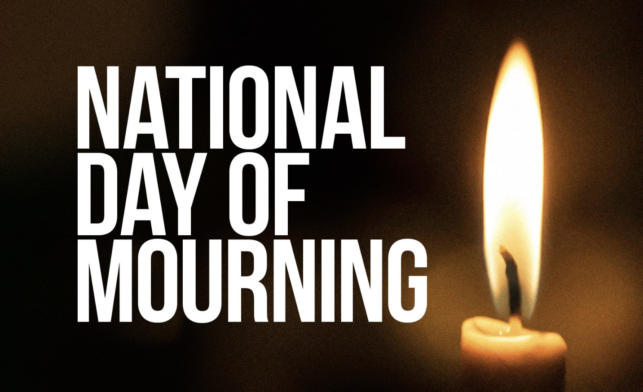

Postal Family Federal Credit Union

Will be CLOSED

Thursday January 9, 2025

In Observance of President Jimmy Carter

National Day of Mourning.