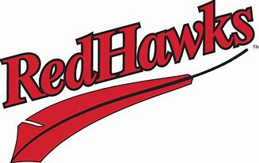

ARE YOU READY FOR THE RED HAWKS?
Join your Postal Family FCU friends for a night of baseball & fun!
On Thursday, August 7th, 2025. Tailgating meal is served in the east parking lot.
Starting at 6 p.m., followed by the game at 7:02 p.m.
Tickets are only $10 and are on sale now!
Stop in or call 701-232-6910 to make your reservations today!
The reserved ticket deadline is July 24th. All sales are final.
WE’VE GOT THE BASES COVERED FOR FUN!


